**DS Lab**

**Exp-6**

**Name: Sushant Tulasi**

**Division: D20B**

**Roll no: 60**

**Aim:** To design a Fuzzy Control System using a fuzzy logic tool/library.

**Theory:**

**Fuzzy Control for Temperature Regulation:**

Fuzzy control is ideal for managing systems that require smooth, adaptive decision-making, such as regulating water temperature. Traditional control systems might use fixed thresholds to turn a heating element on or off, which can lead to sudden temperature changes and inefficiency. Fuzzy logic, however, provides a more gradual and precise control by handling inputs that are not sharply defined.

**Application in Water Temperature Regulation:**

The objective of this fuzzy control system is to maintain the water temperature within a comfortable range. The system monitors the water temperature and adjusts the valve's position to control the heating element. When the water temperature drops, the system increases the heating intensity, and when the water reaches the desired temperature, the system reduces or stops the heating, ensuring a consistent and comfortable water temperature.

**Key Components:**

1. **Input Fuzzification:**
   * The input is the current water temperature, which is fuzzified into categories such as "cold," "warm," and "hot."
2. **Rule Base:**
   * The fuzzy rules define how the system should respond based on the input. For example, "If the water is cold, open the valve wide."
3. **Inference Mechanism:**
   * The rules are applied to the current fuzzified inputs to generate a fuzzy output.
4. **Aggregation and Defuzzification:**
   * The fuzzy outputs are combined and then defuzzified into a crisp value, which controls the valve position.

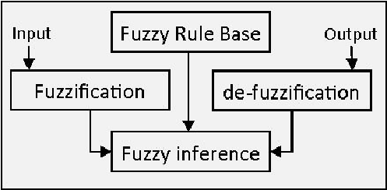

**Code:**

!pip install scikit-fuzzy

import numpy as np

import skfuzzy as fuzz

from skfuzzy import control as ctrl

import matplotlib.pyplot as plt

# Define input and output variables

temperature = ctrl.Antecedent(np.arange(0, 101, 1), 'temperature')

fan_speed = ctrl.Consequent(np.arange(0, 101, 1), 'fan_speed')

# Define membership functions for temperature

temperature['low'] = fuzz.trimf(temperature.universe, [0, 0, 50])

temperature['medium'] = fuzz.trimf(temperature.universe, [25, 50, 75])

temperature['high'] = fuzz.trimf(temperature.universe, [50, 100, 100])

# Define membership functions for fan speed

fan_speed['slow'] = fuzz.trimf(fan_speed.universe, [0, 0, 50])

fan_speed['moderate'] = fuzz.trimf(fan_speed.universe, [25, 50, 75])

fan_speed['fast'] = fuzz.trimf(fan_speed.universe, [50, 100, 100])

# Define fuzzy rules

rule1 = ctrl.Rule(temperature['low'], fan_speed['slow'])

rule2 = ctrl.Rule(temperature['medium'], fan_speed['moderate'])

rule3 = ctrl.Rule(temperature['high'], fan_speed['fast'])

# Create the control system

fan_ctrl = ctrl.ControlSystem([rule1, rule2, rule3])

fan = ctrl.ControlSystemSimulation(fan_ctrl)

# Pass inputs to the control system

fan.input['temperature'] = 75

fan.compute()

# Output the result

print(fan.output['fan_speed'])

# Plotting the membership functions for temperature

temperature.view()

# Plotting the membership functions for fan speed

fan_speed.view()

# Generating the control surface

temperature_range = np.linspace(0, 100, 100)

fan_speed_result = np.zeros_like(temperature_range)

for i, temp in enumerate(temperature_range):

fan.input['temperature'] = temp

fan.compute()

fan_speed_result[i] = fan.output['fan_speed']

plt.figure(figsize=(8, 6))

plt.plot(temperature_range, fan_speed_result, label='Fan Speed', color='blue')

plt.title('Control Surface: Fan Speed vs Temperature')

plt.xlabel('Temperature')

plt.ylabel('Fan Speed')

plt.legend()

plt.grid(True)

plt.show()

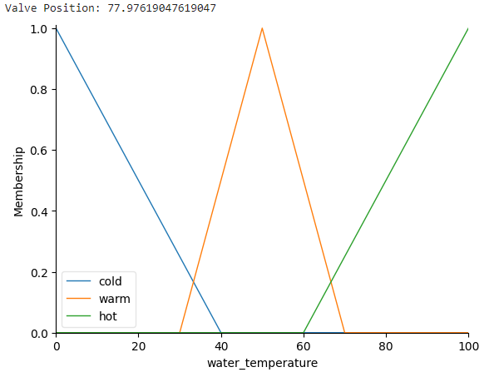

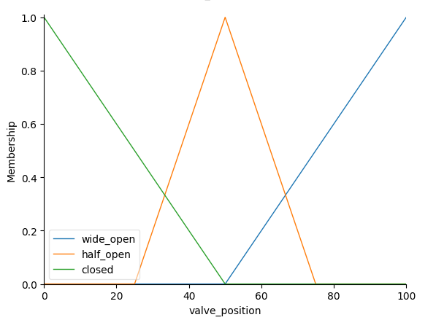

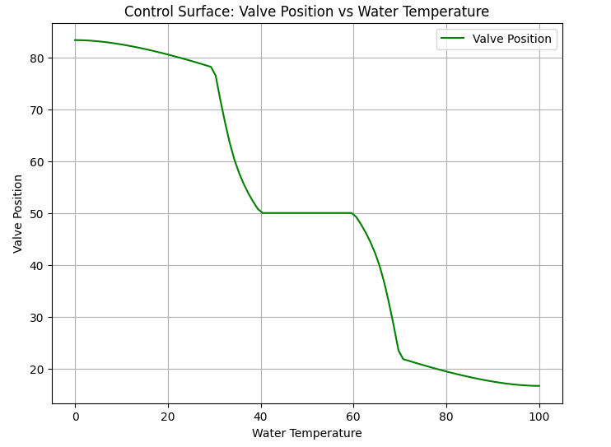

**Conclusion:**

This fuzzy control experiment illustrates how a temperature-based valve can be effectively managed using fuzzy logic. The system automatically adjusts the valve's position to maintain a desired water temperature, ensuring comfort and efficiency. By handling the input temperature data with fuzzy logic, the system provides smooth, adaptive control over the water heating process, avoiding the sudden temperature changes that might occur with traditional on/off controls.